* Relationships of independent variables to Leaf N, with site as a random factor
  + NOx for 2013 not significant
  + NOx for Dec 2013 not significant
  + Percent Urban not significant
  + Soil NH4-N not significant
  + DBH not significant
  + Soil NO3-N is significant, but small effect

Fixed effects:

Estimate Std. Error df t value Pr(>|t|)

(Intercept) 1.893e-02 1.357e-03 4.754e+01 13.944 <2e-16 ***

soil.no3.n 2.033e-04 9.517e-05 5.195e+01 2.136 0.0374 *

---

Signif. codes: 0 ‘***’ 0.001 ‘**’ 0.01 ‘*’ 0.05 ‘.’ 0.1 ‘ ’ 1

* + Leaf percent herbivory is significant, but small effect

Fixed effects:

Estimate Std. Error df t value Pr(>|t|)

(Intercept) 2.066e-02 5.971e-04 1.722e+01 34.597 <2e-16 ***

leaf.pct.herb 1.334e-02 5.541e-03 4.353e+01 2.407 0.0204 *

---

Signif. codes: 0 ‘***’ 0.001 ‘**’ 0.01 ‘*’ 0.05 ‘.’ 0.1 ‘ ’ 1

# Looking at data if you average everything to one value per site

* Nothing is significant.

Call:

lm(formula = leaf.pct.n ~ dbh.cm + nox.yr.2013 + soil.nh4.n +

soil.no3.n)

Residuals:

Min 1Q Median 3Q Max

-0.0018878 -0.0011913 0.0003515 0.0010042 0.0020196

Coefficients:

Estimate Std. Error t value Pr(>|t|)

(Intercept) 1.792e-02 4.518e-03 3.965 0.00741 **

dbh.cm 7.436e-05 5.578e-05 1.333 0.23086

nox.yr.2013 1.267e-05 2.473e-04 0.051 0.96080

soil.nh4.n -9.123e-05 1.912e-04 -0.477 0.65016

soil.no3.n 5.713e-05 2.940e-04 0.194 0.85237

---

Signif. codes: 0 ‘***’ 0.001 ‘**’ 0.01 ‘*’ 0.05 ‘.’ 0.1 ‘ ’ 1

Residual standard error: 0.001771 on 6 degrees of freedom

Multiple R-squared: 0.2493, Adjusted R-squared: -0.2512

F-statistic: 0.4981 on 4 and 6 DF, p-value: 0.7395

No differences when you separate sites into urban/rural categories

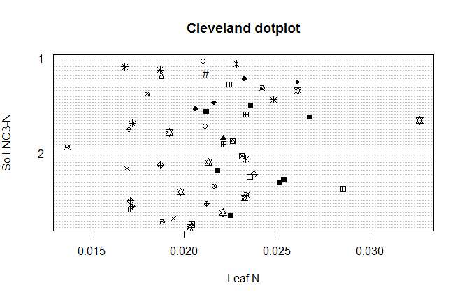

* Write out specific hypotheses and like NOx should affect soil N, test, see if supported
* Put all of the vars in and see what happens
* Put all of the vars in as * and see what happens
* Do the above with the step function to remove factors that aren’t important

Date doesn’t influence anything

Including data and site as random factors doesn’t do anything.

Regular multiple regression has similar results to lmer – only no3 significant, but doesn’t mean anything.

Do lmers with site and date as random factors for leaf herbivory and for soil N etc.

Lmer with numbers instead of pcts. removed scale warnings.

Linear mixed model fit by REML

t-tests use Satterthwaite approximations to degrees of freedom ['merModLmerTest']

Formula: leaf.pct.herb.num ~ nox.yr.2013 + soil.no3.n + soil.nh4.n + pct.urban.num + dbh.cm + leaf.pct.n.num + (1 | site)

Data: all.data

REML criterion at convergence: 347.9

Scaled residuals:

Min 1Q Median 3Q Max

-2.1298 -0.3839 -0.0450 0.3307 4.0821

Random effects:

Groups Name Variance Std.Dev.

site (Intercept) 7.569 2.751

Residual 38.895 6.237

Number of obs: 53, groups: site, 11

Fixed effects:

Estimate Std. Error df t value Pr(>|t|)

(Intercept) 9.07950 12.17441 29.00000 0.746 0.4618

nox.yr.2013 -2.36716 1.16693 14.39000 -2.029 0.0614 .

soil.no3.n 0.57731 0.23751 45.57000 2.431 0.0191 *

soil.nh4.n -0.39031 0.16796 45.12000 -2.324 0.0247 *

pct.urban.num 0.26408 0.09222 13.76000 2.863 0.0127 *

dbh.cm -0.16865 0.07804 44.51000 -2.161 0.0361 *

leaf.pct.n.num 5.62737 2.88907 45.80000 1.948 0.0576 .

---

Signif. codes: 0 ‘***’ 0.001 ‘**’ 0.01 ‘*’ 0.05 ‘.’ 0.1 ‘ ’ 1

Correlation of Fixed Effects:

(Intr) n..201 sl.n3. sl.n4. pct.r. dbh.cm

nox.yr.2013 -0.818

soil.no3.n -0.114 0.001

soil.nh4.n -0.208 0.336 -0.474

pct.urbn.nm 0.689 -0.887 -0.016 -0.289

dbh.cm -0.666 0.572 0.024 0.242 -0.569

lf.pct.n.nm -0.450 0.009 -0.171 -0.142 -0.032 0.007

Lmer with asin

Linear mixed model fit by REML

t-tests use Satterthwaite approximations to degrees of freedom ['merModLmerTest']

Formula: asin(leaf.pct.herb) ~ nox.yr.2013 + soil.no3.n + soil.nh4.n + asin(pct.urban) + dbh.cm + asin(leaf.pct.n) + (1 | site)

Data: all.data

REML criterion at convergence: -91.1

Scaled residuals:

Min 1Q Median 3Q Max

-2.0734 -0.3640 -0.0485 0.3488 4.2171

Random effects:

Groups Name Variance Std.Dev.

site (Intercept) 0.0006557 0.02561

Residual 0.0041941 0.06476

Number of obs: 53, groups: site, 11

Fixed effects:

Estimate Std. Error df t value Pr(>|t|)

(Intercept) 0.1051017 0.1226975 28.2300000 0.857 0.39888

nox.yr.2013 -0.0246060 0.0112041 13.8000000 -2.196 0.04569 *

soil.no3.n 0.0059645 0.0024504 45.8100000 2.434 0.01889 *

soil.nh4.n -0.0040193 0.0017236 45.6200000 -2.332 0.02418 *

asin(pct.urban) 0.2362002 0.0758766 13.3900000 3.113 0.00799 **

dbh.cm -0.0017869 0.0007886 42.4700000 -2.266 0.02860 *

asin(leaf.pct.n) 5.6323965 2.9809091 45.9500000 1.889 0.06515 .

---

Signif. codes: 0 ‘***’ 0.001 ‘**’ 0.01 ‘*’ 0.05 ‘.’ 0.1 ‘ ’ 1

Correlation of Fixed Effects:

(Intr) n..201 sl.n3. sl.n4. asn(.) dbh.cm

nox.yr.2013 -0.814

soil.no3.n -0.114 -0.004

soil.nh4.n -0.192 0.327 -0.481

asn(pct.rb) 0.687 -0.879 -0.012 -0.276

dbh.cm -0.660 0.566 0.021 0.223 -0.564

asn(lf.pc.) -0.472 0.025 -0.168 -0.138 -0.052 0.013

Warning messages:

1: Some predictor variables are on very different scales: consider rescaling

Residuals for leaf.herb.17

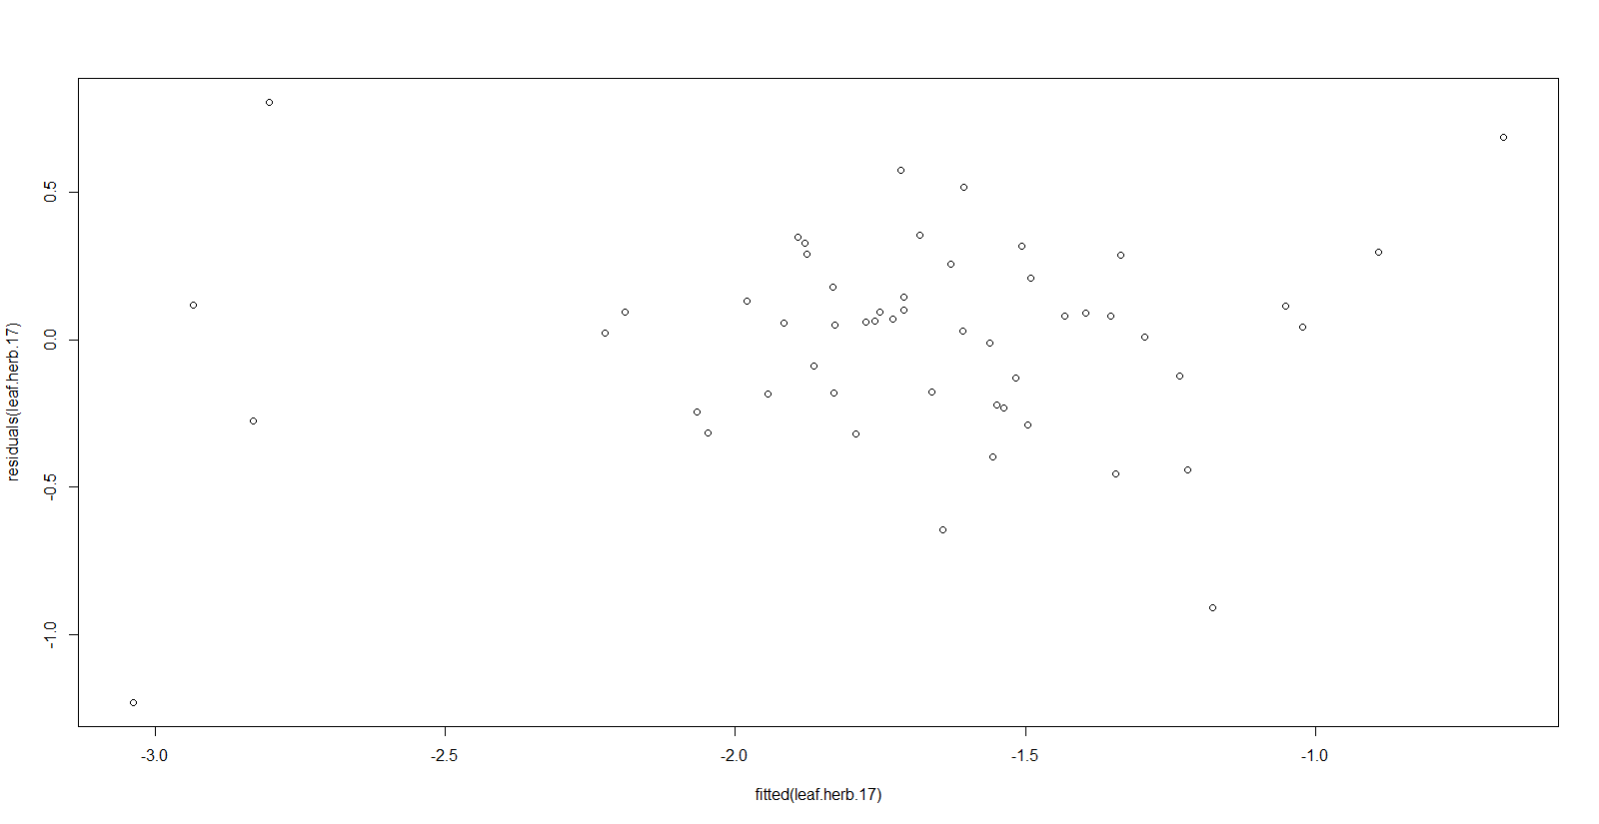

Cook’s Distance values for leaf.herb.17 aka leaf.herb.i0. this has all percentages inverse transformed

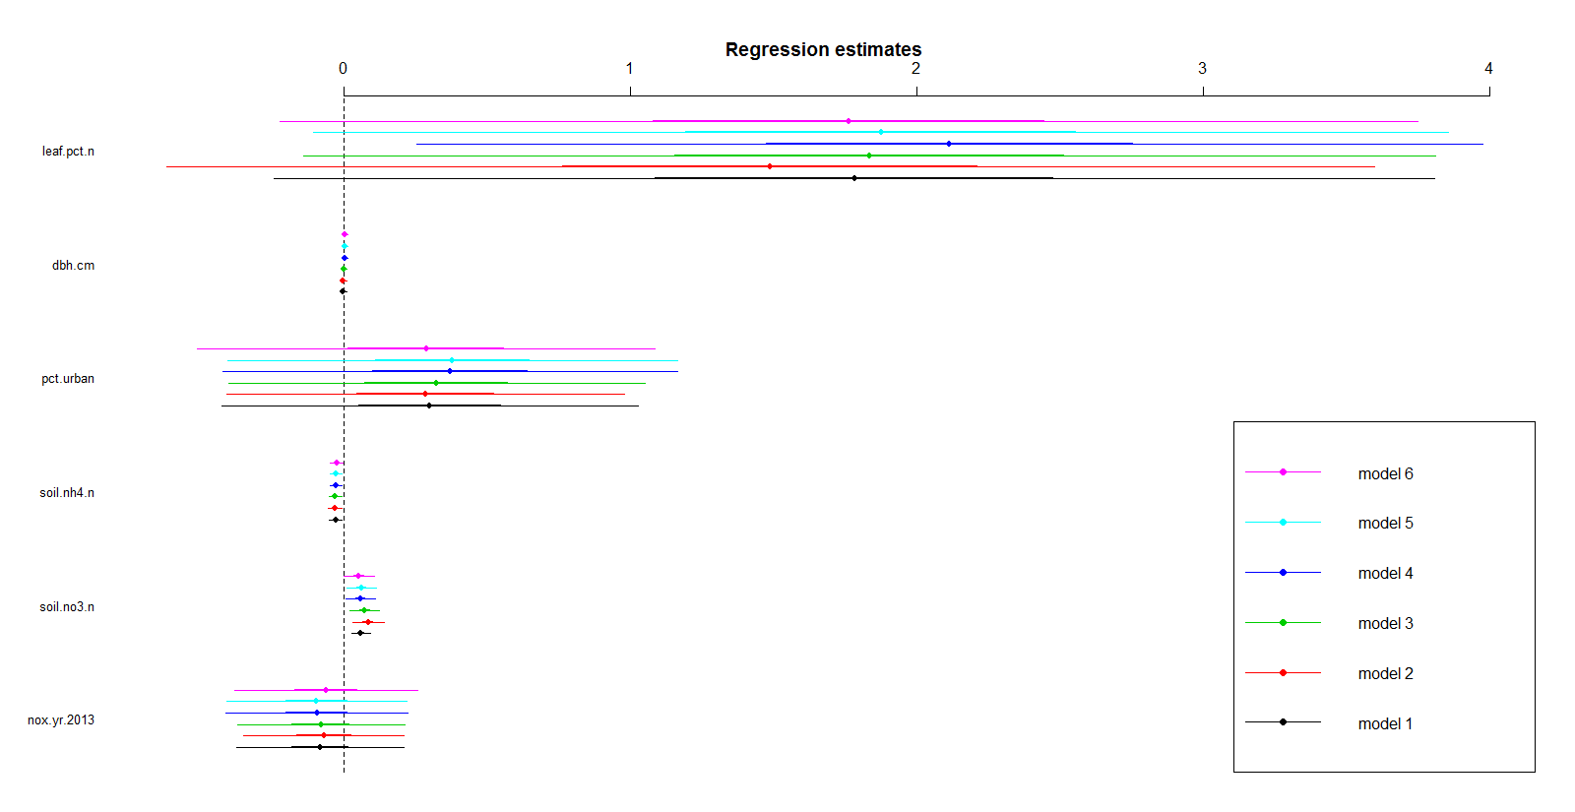

Dots represent the coefficient (slope), dark bars are 1 standard error, light bars are 2 standard errors

Model 1 is with no outliers, model 6 is with 5 outliers removed

If the bars don’t cross zero, the var should be significant

The direction and magnitude of the model coefficients doesn’t change based on outliers being dropped.

Just keep the outliers in because of this.

Use the significance from leaf.herb.i0 (below), not leaf.herb.i5.

> summary(leaf.herb.i0)

Linear mixed model fit by REML t-tests use Satterthwaite approximations to degrees of freedom [merModLmerTest

]

Formula: leaf.pct.herb ~ nox.yr.2013 + soil.no3.n + soil.nh4.n + pct.urban +

dbh.cm + leaf.pct.n + (1 | site)

Data: all.data

REML criterion at convergence: 97.4

Scaled residuals:

Min 1Q Median 3Q Max

-2.9828 -0.4468 0.1479 0.4304 1.9497

Random effects:

Groups Name Variance Std.Dev.

site (Intercept) 0.2195 0.4685

Residual 0.1694 0.4116

Number of obs: 53, groups: site, 11

Fixed effects:

Estimate Std. Error df t value Pr(>|t|)

(Intercept) 2.227633 2.690741 41.960000 0.828 0.412417

nox.yr.2013 -0.080536 0.148834 10.500000 -0.541 0.599723

soil.no3.n 0.061108 0.016458 40.890000 3.713 0.000612 ***

soil.nh4.n -0.026868 0.011535 40.790000 -2.329 0.024875 *

pct.urban 0.301324 0.370165 10.090000 0.814 0.434421

dbh.cm -0.001163 0.005623 43.480000 -0.207 0.837110

leaf.pct.n 1.782656 1.033248 41.200000 1.725 0.091969 .

---

Signif. codes: 0 ‘***’ 0.001 ‘**’ 0.01 ‘*’ 0.05 ‘.’ 0.1 ‘ ’ 1

Correlation of Fixed Effects:

(Intr) n..201 sl.n3. sl.n4. pct.rb dbh.cm

nox.yr.2013 -0.588

soil.no3.n -0.223 0.007

soil.nh4.n -0.238 0.221 -0.458

pct.urban 0.526 -0.892 -0.011 -0.191

dbh.cm -0.312 0.380 0.039 0.270 -0.365

leaf.pct.n 0.794 0.006 -0.196 -0.113 -0.016 0.012

> summary(leaf.herb.i5)

Linear mixed model fit by REML t-tests use Satterthwaite approximations to degrees of freedom [merModLmerTest

]

Formula: leaf.pct.herb ~ nox.yr.2013 + soil.no3.n + soil.nh4.n + pct.urban +

dbh.cm + leaf.pct.n + (1 | site)

Data: all.data.out5

REML criterion at convergence: 81.3

Scaled residuals:

Min 1Q Median 3Q Max

-3.2096 -0.4517 0.0645 0.4729 2.2896

Random effects:

Groups Name Variance Std.Dev.

site (Intercept) 0.2818 0.5309

Residual 0.1280 0.3577

Number of obs: 48, groups: site, 11

Fixed effects:

Estimate Std. Error df t value Pr(>|t|)

(Intercept) 1.819040 2.829101 36.570000 0.643 0.5243

nox.yr.2013 -0.061248 0.162468 9.610000 -0.377 0.7144

soil.no3.n 0.053948 0.026999 38.550000 1.998 0.0528 .

soil.nh4.n -0.023097 0.011346 34.090000 -2.036 0.0496 *

pct.urban 0.288066 0.407197 9.500000 0.707 0.4963

dbh.cm 0.004791 0.005398 37.000000 0.888 0.3805

leaf.pct.n 1.763088 1.013593 36.340000 1.739 0.0904 .

---

Signif. codes: 0 ‘***’ 0.001 ‘**’ 0.01 ‘*’ 0.05 ‘.’ 0.1 ‘ ’ 1

Correlation of Fixed Effects:

(Intr) n..201 sl.n3. sl.n4. pct.rb dbh.cm

nox.yr.2013 -0.637

soil.no3.n -0.344 0.025

soil.nh4.n -0.147 0.192 -0.544

pct.urban 0.565 -0.890 0.002 -0.185

dbh.cm -0.206 0.315 -0.113 0.301 -0.307

leaf.pct.n 0.784 -0.042 -0.329 -0.054 0.024 0.086

Also checked log transform, didn’t make things any better; did show same direction of coeffs.

Now I need to untransform coefficients and intercepts so that I can say that nh4 was significant, but leaf.pct.n had the most influence and was marginally significant.

Then I need to say that an increase in 1 pct leaf n yields x amt of increase in herbivory

# Important Variables and Correlations

leaf.pct.n leaf.pct.herb dbh.cm pct.urban nox.yr.2013 soil.no3.n soil.nh4.n

leaf.pct.n 1.00000 0.072780 0.1026402 -0.015126 0.01663 0.121587 0.079359

leaf.pct 0.07278 1.00000 -0.00146 0.238307 0.07993 0.10090 -0.066061

dbh.cm 0.10264 -0.001462 1.00000 0.230939 0.09267 -0.00804 0.059233

pct.urban -0.01511 0.238307 0.230939 1.000000 0.66300 -0.08524 -0.008298

nox.yr.2013 0.01663 0.079938 0.092679 0.663009 1.00000 -0.18935 -0.178795

soil.no3.n 0.12158 0.100907 -0.008044 -0.085248 -0.18935 1.00000 0.472040

soil.nh4.n 0.07935 -0.066061 0.059233 -0.008298 -0.17879 0.472040 1.000000

# Effects on Leaf N

* Log transformed all percent measurements – leaf.pct.n, pct.urban, leaf.pct.herb
* Did linear mixed effects model with site as random factor and nox.yr.2013, soil.no3.n, soil.nh4.n, pct.urban, dbh.cm, leaf.pct.herb as predictor variables
* Nothing significant (see lmer below)
* Also split into urban/rural categories and still nothing significant

Linear mixed model fit by REML

t-tests use Satterthwaite approximations to degrees of freedom ['merModLmerTest']

Formula: leaf.pct.n ~ nox.yr.2013 + soil.no3.n + soil.nh4.n + pct.urban + dbh.cm + leaf.pct.herb + (1 | site)

Data: all.data

REML criterion at convergence: -2.9

Scaled residuals:

Min 1Q Median 3Q Max

-2.6204 -0.4672 0.2279 0.6736 1.9753

Random effects:

Groups Name Variance Std.Dev.

site (Intercept) 0.002157 0.04644

Residual 0.021654 0.14715

Number of obs: 53, groups: site, 11

Fixed effects:

Estimate Std. Error df t value Pr(>|t|)

(Intercept) -4.204196 0.421654 13.070000 -9.971 1.77e-07 ***

nox.yr.2013 0.025209 0.030729 11.180000 0.820 0.429

soil.no3.n 0.003038 0.005765 43.060000 0.527 0.601

soil.nh4.n 0.005029 0.003862 45.800000 1.302 0.199

pct.urban -0.052831 0.066240 10.160000 -0.798 0.443

dbh.cm 0.001154 0.001653 33.420000 0.698 0.490

leaf.pct.herb 0.025034 0.015176 23.740000 1.650 0.112

---

Signif. codes: 0 ‘***’ 0.001 ‘**’ 0.01 ‘*’ 0.05 ‘.’ 0.1 ‘ ’ 1

Correlation of Fixed Effects:

(Intr) n..201 sl.n3. sl.n4. pct.rb dbh.cm

nox.yr.2013 -0.958

soil.no3.n -0.113 -0.069

soil.nh4.n -0.267 0.322 -0.560

pct.urban 0.916 -0.932 0.062 -0.278

dbh.cm -0.655 0.535 -0.018 0.188 -0.514

lef.pct.hrb 0.080 0.085 -0.337 0.178 -0.103 0.037

# Effects on Leaf Herbivory

* Log transformed all percent measurements – leaf.pct.n, pct.urban, leaf.pct.herb
* Did linear mixed effects model with site as random factor and nox.yr.2013, soil.no3.n, soil.nh4.n, pct.urban, dbh.cm, leaf.pct.n as predictor variables
* soil.no3.n significant, but small slope
* soil.nh4.n marginally significant, but smaller slope
* leaf.pct.n not significant, but has the most influence on herbivory

> summary(leaf.herb.i0)

Linear mixed model fit by REML

t-tests use Satterthwaite approximations to degrees of freedom ['merModLmerTest']

Formula: leaf.pct.herb ~ nox.yr.2013 + soil.no3.n + soil.nh4.n + pct.urban + dbh.cm + leaf.pct.n + (1 | site)

Data: all.data

REML criterion at convergence: 187.7

Scaled residuals:

Min 1Q Median 3Q Max

-4.2025 -0.3915 0.1063 0.3295 2.3984

Random effects:

Groups Name Variance Std.Dev.

site (Intercept) 1.625 1.275

Residual 1.145 1.070

Number of obs: 53, groups: site, 11

Fixed effects:

Estimate Std. Error df t value Pr(>|t|)

(Intercept) 2.204246 7.253204 27.140000 0.304 0.76352

nox.yr.2013 -0.053748 0.443750 9.790000 -0.121 0.90604

soil.no3.n 0.148623 0.042856 40.760000 3.468 0.00125 **

soil.nh4.n -0.054942 0.029934 41.000000 -1.835 0.07370 .

pct.urban 0.216469 0.981132 9.330000 0.221 0.83013

dbh.cm 0.007583 0.014419 44.630000 0.526 0.60159

leaf.pct.n 1.701369 1.120760 40.970000 1.518 0.13668

---

Signif. codes: 0 ‘***’ 0.001 ‘**’ 0.01 ‘*’ 0.05 ‘.’ 0.1 ‘ ’ 1

Correlation of Fixed Effects:

(Intr) n..201 sl.n3. sl.n4. pct.rb dbh.cm

nox.yr.2013 -0.776

soil.no3.n -0.186 0.005

soil.nh4.n -0.237 0.200 -0.460

pct.urban 0.734 -0.912 -0.009 -0.170

dbh.cm -0.349 0.330 0.040 0.263 -0.308

leaf.pct.n 0.637 -0.032 -0.197 -0.116 0.027 -0.006

05.20.15

#initial working model for leaf herb

leafherb.nums<- lmer(leaf.pct.herb.num ~ nox.yr.2013 + soil.no3.n + soil.nh4.n + pct.urban.num +

dbh.cm + leaf.pct.n.num + (1 | site))

Linear mixed model fit by REML

t-tests use Satterthwaite approximations to degrees of freedom ['merModLmerTest']

Formula: leaf.pct.herb.num ~ nox.yr.2013 + soil.no3.n + soil.nh4.n + pct.urban.num + dbh.cm + leaf.pct.n.num + (1 | site)

REML criterion at convergence: 347.9

Scaled residuals:

Min 1Q Median 3Q Max

-2.1298 -0.3839 -0.0450 0.3307 4.0821

Random effects:

Groups Name Variance Std.Dev.

site (Intercept) 7.569 2.751

Residual 38.895 6.237

Number of obs: 53, groups: site, 11

Fixed effects:

Estimate Std. Error df t value Pr(>|t|)

(Intercept) 9.07950 12.17441 29.00000 0.746 0.4618

nox.yr.2013 -2.36716 1.16693 14.39000 -2.029 0.0614 .

soil.no3.n 0.57731 0.23751 45.57000 2.431 0.0191 *

soil.nh4.n -0.39031 0.16796 45.12000 -2.324 0.0247 *

pct.urban.num 0.26408 0.09222 13.76000 2.863 0.0127 *

dbh.cm -0.16865 0.07804 44.51000 -2.161 0.0361 *

leaf.pct.n.num 5.62737 2.88907 45.80000 1.948 0.0576 .

---

Signif. codes: 0 ‘***’ 0.001 ‘**’ 0.01 ‘*’ 0.05 ‘.’ 0.1 ‘ ’ 1

Correlation of Fixed Effects:

(Intr) n..201 sl.n3. sl.n4. pct.r. dbh.cm

nox.yr.2013 -0.818

soil.no3.n -0.114 0.001

soil.nh4.n -0.208 0.336 -0.474

pct.urbn.nm 0.689 -0.887 -0.016 -0.289

dbh.cm -0.666 0.572 0.024 0.242 -0.569

lf.pct.n.nm -0.450 0.009 -0.171 -0.142 -0.032 0.007

Residuals for leafherb.nums

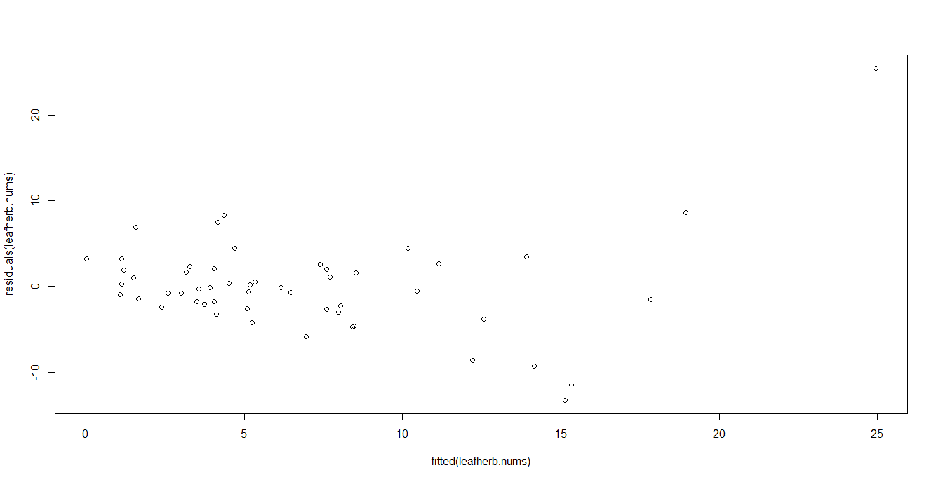

# leaf herb lmer with pct.urban.num removed b/c it's highly correlated with nox.yr.2013

Linear mixed model fit by REML

t-tests use Satterthwaite approximations to degrees of freedom ['merModLmerTest']

Formula: leaf.pct.herb.num ~ nox.yr.2013 + soil.no3.n + soil.nh4.n + dbh.cm + leaf.pct.n.num + (1 | site)

REML criterion at convergence: 351.4

Scaled residuals:

Min 1Q Median 3Q Max

-2.1886 -0.3076 -0.0530 0.1992 4.4302

Random effects:

Groups Name Variance Std.Dev.

site (Intercept) 20.33 4.509

Residual 39.35 6.273

Number of obs: 53, groups: site, 11

Fixed effects:

Estimate Std. Error df t value Pr(>|t|)

(Intercept) -12.55207 10.43013 23.18000 -1.203 0.2410

nox.yr.2013 0.54852 0.71912 8.75000 0.763 0.4657

soil.no3.n 0.59829 0.24582 43.63000 2.434 0.0191 *

soil.nh4.n -0.28398 0.16789 45.31000 -1.691 0.0976 .

dbh.cm -0.06661 0.07251 40.19000 -0.919 0.3637

leaf.pct.n.num 5.63056 2.99695 44.07000 1.879 0.0669 .

---

Signif. codes: 0 ‘***’ 0.001 ‘**’ 0.01 ‘*’ 0.05 ‘.’ 0.1 ‘ ’ 1

Correlation of Fixed Effects:

(Intr) n..201 sl.n3. sl.n4. dbh.cm

nox.yr.2013 -0.694

soil.no3.n -0.125 -0.014

soil.nh4.n -0.053 0.149 -0.480

dbh.cm -0.474 0.159 0.025 0.161

lf.pct.n.nm -0.525 -0.032 -0.185 -0.152 0.015

Residuals for leafherb.nums1

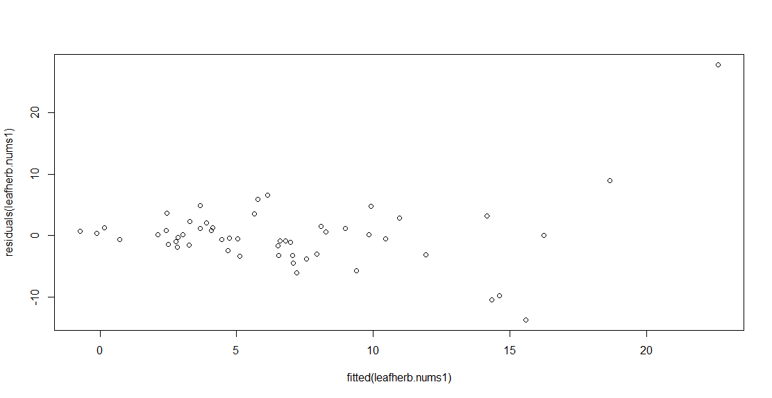

# leaf herbivory lmer with removed nox.yr.2013

leafherb.nums2<- lmer(leaf.pct.herb.num ~ pct.urban.num + soil.no3.n + soil.nh4.n +

dbh.cm + leaf.pct.n.num + (1 | site))

summary(leafherb.nums2)

Linear mixed model fit by REML

t-tests use Satterthwaite approximations to degrees of freedom ['merModLmerTest']

Formula: leaf.pct.herb.num ~ pct.urban.num + soil.no3.n + soil.nh4.n + dbh.cm + leaf.pct.n.num + (1 | site)

REML criterion at convergence: 353.7

Scaled residuals:

Min 1Q Median 3Q Max

-2.1727 -0.3586 -0.0620 0.2675 4.4072

Random effects:

Groups Name Variance Std.Dev.

site (Intercept) 13.42 3.663

Residual 38.93 6.239

Number of obs: 53, groups: site, 11

Fixed effects:

Estimate Std. Error df t value Pr(>|t|)

(Intercept) -10.51342 7.35299 42.17000 -1.430 0.1601

pct.urban.num 0.09895 0.04976 8.84000 1.988 0.0786 .

soil.no3.n 0.58660 0.24175 45.00000 2.427 0.0193 *

soil.nh4.n -0.29082 0.16220 46.63000 -1.793 0.0795 .

dbh.cm -0.08578 0.06843 36.26000 -1.254 0.2180

leaf.pct.n.num 5.55435 2.94525 45.41000 1.886 0.0657 .

---

Signif. codes: 0 ‘***’ 0.001 ‘**’ 0.01 ‘*’ 0.05 ‘.’ 0.1 ‘ ’ 1

Correlation of Fixed Effects:

(Intr) pct.r. sl.n3. sl.n4. dbh.cm

pct.urbn.nm -0.182

soil.no3.n -0.186 -0.025

soil.nh4.n 0.093 0.010 -0.492

dbh.cm -0.448 -0.147 0.029 0.107

lf.pct.n.nm -0.749 -0.049 -0.179 -0.152 0.017

Residuals for leafherb.nums2

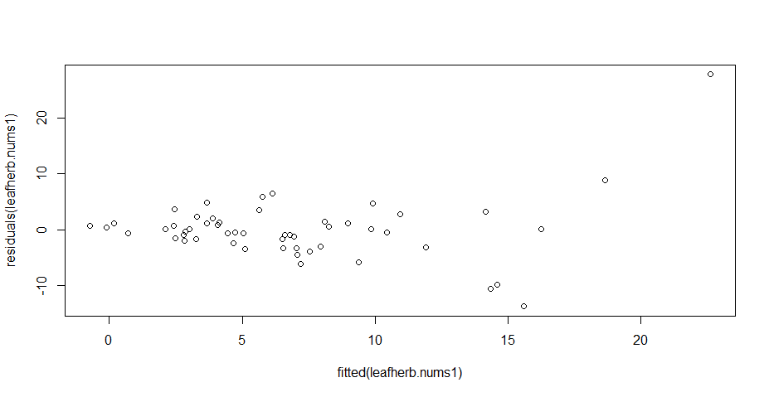

#initial working model for leaf n

leafn.nums<- lmer(leaf.pct.n.num ~ nox.yr.2013 + soil.no3.n + soil.nh4.n + leaf.pct.herb.num +

dbh.cm + pct.urban.num + (1|site))

summary(leafn.nums)

Linear mixed model fit by REML

t-tests use Satterthwaite approximations to degrees of freedom ['merModLmerTest']

Formula: leaf.pct.n.num ~ nox.yr.2013 + soil.no3.n + soil.nh4.n + leaf.pct.herb.num + dbh.cm + pct.urban.num + (1 | site)

REML criterion at convergence: 76.3

Scaled residuals:

Min 1Q Median 3Q Max

-2.12331 -0.53550 0.08391 0.63335 2.30674

Random effects:

Groups Name Variance Std.Dev.

site (Intercept) 0.008682 0.09318

Residual 0.097634 0.31246

Number of obs: 53, groups: site, 11

Fixed effects:

Estimate Std. Error df t value Pr(>|t|)

(Intercept) 1.579869 0.523926 26.260000 3.015 0.00563 **

nox.yr.2013 0.033216 0.055128 16.440000 0.603 0.55505

soil.no3.n 0.004374 0.012328 45.920000 0.355 0.72436

soil.nh4.n 0.013267 0.008520 45.880000 1.557 0.12630

leaf.pct.herb.num 0.013809 0.006891 44.540000 2.004 0.05117 .

dbh.cm 0.002724 0.003952 42.740000 0.689 0.49440

pct.urban.num -0.003043 0.004547 17.730000 -0.669 0.51201

---

Signif. codes: 0 ‘***’ 0.001 ‘**’ 0.01 ‘*’ 0.05 ‘.’ 0.1 ‘ ’ 1

Correlation of Fixed Effects:

(Intr) n..201 sl.n3. sl.n4. lf.p.. dbh.cm

nox.yr.2013 -0.920

soil.no3.n -0.100 -0.115

soil.nh4.n -0.364 0.418 -0.566

lf.pct.hrb. -0.272 0.307 -0.361 0.282

dbh.cm -0.784 0.646 -0.095 0.299 0.308

pct.urbn.nm 0.791 -0.903 0.136 -0.392 -0.417 -0.655

# leafn lmer with pct.urban.num removed

leafn.nums1<- lmer(leaf.pct.n.num ~ nox.yr.2013 + soil.no3.n + soil.nh4.n + leaf.pct.herb.num +

dbh.cm + (1|site))

summary(leafn.nums1)

Linear mixed model fit by REML

t-tests use Satterthwaite approximations to degrees of freedom ['merModLmerTest']

Formula: leaf.pct.n.num ~ nox.yr.2013 + soil.no3.n + soil.nh4.n + leaf.pct.herb.num + dbh.cm + pct.urban.num + (1 | site)

REML criterion at convergence: 76.3

Scaled residuals:

Min 1Q Median 3Q Max

-2.12331 -0.53550 0.08391 0.63335 2.30674

Random effects:

Groups Name Variance Std.Dev.

site (Intercept) 0.008682 0.09318

Residual 0.097634 0.31246

Number of obs: 53, groups: site, 11

Fixed effects:

Estimate Std. Error df t value Pr(>|t|)

(Intercept) 1.579869 0.523926 26.260000 3.015 0.00563 **

nox.yr.2013 0.033216 0.055128 16.440000 0.603 0.55505

soil.no3.n 0.004374 0.012328 45.920000 0.355 0.72436

soil.nh4.n 0.013267 0.008520 45.880000 1.557 0.12630

leaf.pct.herb.num 0.013809 0.006891 44.540000 2.004 0.05117 .

dbh.cm 0.002724 0.003952 42.740000 0.689 0.49440

pct.urban.num -0.003043 0.004547 17.730000 -0.669 0.51201

---

Signif. codes: 0 ‘***’ 0.001 ‘**’ 0.01 ‘*’ 0.05 ‘.’ 0.1 ‘ ’ 1

Correlation of Fixed Effects:

(Intr) n..201 sl.n3. sl.n4. lf.p.. dbh.cm

nox.yr.2013 -0.920

soil.no3.n -0.100 -0.115

soil.nh4.n -0.364 0.418 -0.566

lf.pct.hrb. -0.272 0.307 -0.361 0.282

dbh.cm -0.784 0.646 -0.095 0.299 0.308

pct.urbn.nm 0.791 -0.903 0.136 -0.392 -0.417 -0.655

Residuals for leafn.nums

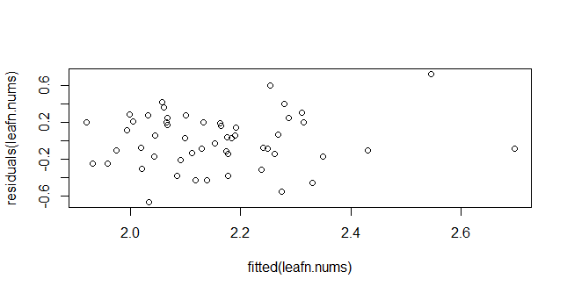

#leafn lmer with pct.urban.num removed

leafn.nums1<- lmer(leaf.pct.n.num ~ nox.yr.2013 + soil.no3.n + soil.nh4.n + leaf.pct.herb.num +

+ dbh.cm + (1|site))

> summary(leafn.nums1)

Linear mixed model fit by REML

t-tests use Satterthwaite approximations to degrees of freedom ['merModLmerTest']

Formula: leaf.pct.n.num ~ nox.yr.2013 + soil.no3.n + soil.nh4.n + leaf.pct.herb.num + dbh.cm + (1 | site)

REML criterion at convergence: 67.8

Scaled residuals:

Min 1Q Median 3Q Max

-2.2353 -0.5719 0.1091 0.6112 2.2930

Random effects:

Groups Name Variance Std.Dev.

site (Intercept) 0.00938 0.09685

Residual 0.09602 0.30986

Number of obs: 53, groups: site, 11

Fixed effects:

Estimate Std. Error df t value Pr(>|t|)

(Intercept) 1.857e+00 3.211e-01 1.474e+01 5.783 3.87e-05 ***

nox.yr.2013 -7.156e-05 2.382e-02 9.570e+00 -0.003 0.9977

soil.no3.n 5.546e-03 1.214e-02 4.695e+01 0.457 0.6500

soil.nh4.n 1.105e-02 7.793e-03 4.675e+01 1.418 0.1627

leaf.pct.herb.num 1.191e-02 6.241e-03 4.020e+01 1.909 0.0635 .

dbh.cm 9.714e-04 2.985e-03 2.495e+01 0.325 0.7476

---

Signif. codes: 0 ‘***’ 0.001 ‘**’ 0.01 ‘*’ 0.05 ‘.’ 0.1 ‘ ’ 1

Correlation of Fixed Effects:

(Intr) n..201 sl.n3. sl.n4. lf.p..

nox.yr.2013 -0.784

soil.no3.n -0.340 0.018

soil.nh4.n -0.097 0.159 -0.562

lf.pct.hrb. 0.102 -0.175 -0.340 0.144

dbh.cm -0.576 0.167 -0.009 0.065 0.054

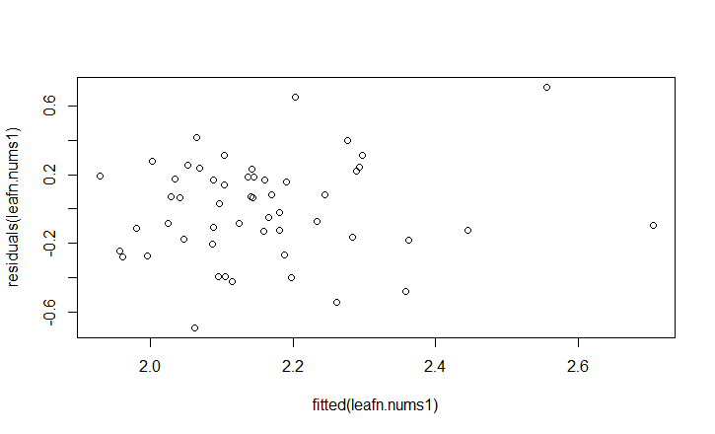

# leafn lmer with nox.yr.2013 removed

leafn.nums2<- lmer(leaf.pct.n.num ~ pct.urban.num + soil.no3.n + soil.nh4.n + leaf.pct.herb.num +

dbh.cm + (1|site))

summary(leafn.nums2)

Linear mixed model fit by REML

t-tests use Satterthwaite approximations to degrees of freedom ['merModLmerTest']

Formula: leaf.pct.n.num ~ pct.urban.num + soil.no3.n + soil.nh4.n + leaf.pct.herb.num + dbh.cm + (1 | site)

REML criterion at convergence: 72.7

Scaled residuals:

Min 1Q Median 3Q Max

-2.22073 -0.61062 0.06858 0.60589 2.31818

Random effects:

Groups Name Variance Std.Dev.

site (Intercept) 0.008802 0.09382

Residual 0.096170 0.31011

Number of obs: 53, groups: site, 11

Fixed effects:

Estimate Std. Error df t value Pr(>|t|)

(Intercept) 1.8703388 0.2042092 22.1300000 9.159 5.52e-09 ***

pct.urban.num -0.0005674 0.0019471 10.0800000 -0.291 0.777

soil.no3.n 0.0052469 0.0121635 46.9200000 0.431 0.668

soil.nh4.n 0.0111299 0.0076901 46.2200000 1.447 0.155

leaf.pct.herb.num 0.0125363 0.0065163 42.9800000 1.924 0.061 .

dbh.cm 0.0011786 0.0030015 25.6000000 0.393 0.698

---

Signif. codes: 0 ‘***’ 0.001 ‘**’ 0.01 ‘*’ 0.05 ‘.’ 0.1 ‘ ’ 1

Correlation of Fixed Effects:

(Intr) pct.r. sl.n3. sl.n4. lf.p..

pct.urbn.nm -0.236

soil.no3.n -0.529 0.075

soil.nh4.n 0.056 -0.040 -0.574

lf.pct.hrb. 0.028 -0.340 -0.345 0.178

dbh.cm -0.637 -0.218 -0.027 0.044 0.151

